Mario Bolivar – Mjb160330

CS 2336.002 – Jason Smith

1/17/18

**Project 1 – Tie Fighter Patrols Pseudocode**

**Steps/Pseudocode:**

* Create a single dimension array to store pilot names – **Size = 20**
* Create a 3-dimensional array to store coordinate values of pilots – **Size = [20] [8] [1] -** *Don’t know how this works yet so will fill in info later.*
* **Read in function: (Takes in pilot names array, 3d array as arguments)** 
  + Open input stream to pilot_routes.txt file - *Don’t know how this works yet so will fill in info later.*
    - Begin reading in information from file
      * While not at the end of file **OR** new line - *Don’t know how this works yet so will fill in info later.*
        + First input the string (Pilot’s name)
        + Then input the x,y coordinates into the three dimensional array
        + Parse x,y input to correctly store the coordinates - *Don’t know how this works yet so will fill in info later.*

Store coordinate information in 3d array

* + - * + **Repeat** until no more coordinates on input/16 times
  + **Close input stream for pilot_routes.txt if java doesn’t close automatically.**
* **Output to file function: (Takes in pilot names array, 3d array as arguments)**
  + Open output stream to pilot_areas.txt file
    - 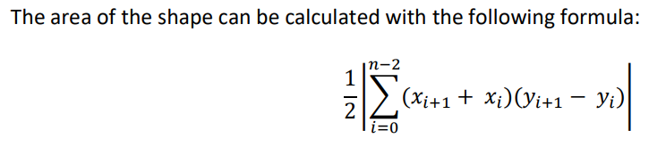Output format: <pilot name><tab><area>
  + **Calculate the area:**
    - Create running sum double variable
    - For loop inside a for loop
      * **1st loop - outer loop**
        + Iterates through pilots
        + Outputs pilot name + area of polygon (aka running sum of current pilot) after second (inner) loop finishes calculating the area.
      * **2nd loop – inner loop**
        + Run iterations of sum formula with array information: (i.e the current pilot array number, # of coordinates for current pilot, coordinate information for pilot, etc) – *Don’t know how this works yet so will fill in info later.*
        + Update running sum through each iteration
        + **At the end of 2nd loop (inner) calculation, the sum (area) of current pilot will be outputted by the 1st loop (outer loop) along with the pilot name + newline char**
      * Repeat until information is done calculating & outputting
  + **Close output stream to pilot_areas.txt if Java doesn’t close automatically.**
* Output string to console when program is finished to indicate whether operations were successful/unsuccessful.
* **Done.**
* **Profit???**

**Pre-Reqs:**

* The file containing main will be Main.java
  + Project files must be in a package named TieFighter
  + Zip contents of the *src* directory (**.zip**)
* Name and netID at the top of all files submitted

**Input:**

* Program must have at least 3 functions
  + At least 2 of the functions must be called from main
* All input will come from a file named pilot_routes.txt
* The file will contain the pilot’s first name followed by a list of coordinates separated by spaces
* Each line in the file will represent a different pilot
* The format for each line will be the pilot’s first name followed by a list of x and y coordinates.
* There will be a space between each pair of coordinates and a comma between the x and y coordinates.
* The first and last set of coordinates will always be the same.
* There may or may not be a new line character at the end of the last line in the file.______________________________________________________________________________

**Output:**

* All output will be written to a file named pilot_areas.txt.
* Output file format
  + <pilot name><tab><area>
* The area should be rounded to 2 decimal places.
* Each pilot’s data will be written on a separate line.

Sample Input Line: Greedo 4,0 4,7.5 7,7.5 7,3 9,0 7,0 4,0

Sample Output Line: Greedo 25.50